CS-330: Final Project
Parker Burkard
June 18, 2026
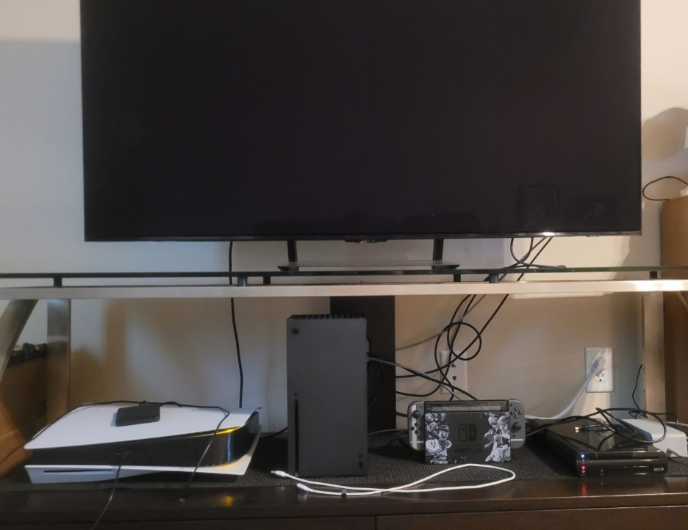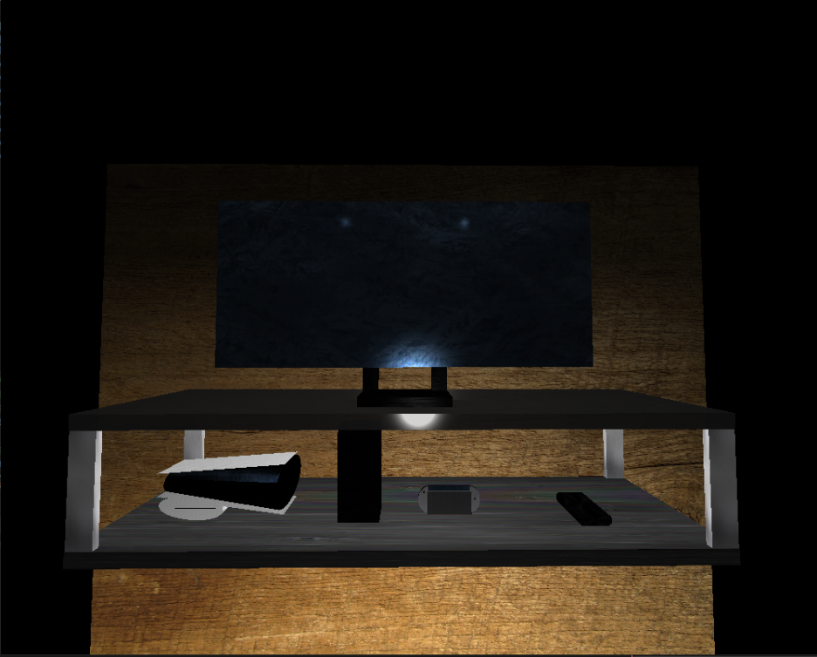

This was an incredibly fun project to work on! I had so much fun learning and playing around with the different objects trying to recreate the image from above. The PlayStation 5 was the most complex object that I had to create as I needed to make the top and bottom panels to hold the body of the PlayStation as well as needing a stand/disc drive on the bottom to stabilize the console. I used planes for the panels as they are quite thin, a tapered cylinder for the body as one end is bigger than the other. I used a cylinder for the stand/disc drive and added an additional cylinder to show the disc drive itself. The Xbox was the simplest design as all I needed was a box to show it off. Next was the Nintendo Switch which needed the docking station as well as the Switch and its joycons to be shown. I wanted to add the thumb sticks (or joysticks) on the side of the Switch to showcase the controllers that are attached to the Nintendo Switch. The last console that I added was the Nintendo WiiU and originally I was going to use a cylinder to show the soft edges but that wasn’t looking good, so I switched to making a box and was planning on wrapping a torus around the box. However, that also wasn’t turning out well, so I decided to morph cylinders on the edges to eliminate the sharp edges to give the WiiU its soft and rounded edges. I also decided to add a background to the environment so darker objects wouldn’t fade into the black. Finally, I added the glass table to support the TV on top and added pillars to combine the wooden table on bottom with the glass table on top.
Users can navigate this environment through the WASD keys to move the camera in/out and from side to side. The Q and E controls will navigate the camera up and down. The mouse can also be used to affect the camera as wherever the user points the mouse towards, the mouse will rotate the camera that way. This allows the user to have full control over the camera making it so they can go anywhere they desire inside the environment.
Some functions that I relied on to complete this assignment were LoadSceneTextures() to load in textures that I found/used from the OpenGL sample. This helped me create believable scenes by loading in textures. The next function that greatly assisted me was the DefineObjectMaterials() function as this helped me with creating the lighting on each object located in the environment, I was able to give glass its sharp reflective properties while some plastic items needed much less specular light to reflect off its surface. Another function that was necessary was the SetupSceneLights() which created the lighting and its positioning to properly illuminate the environment. Lastly, the RenderScene() function where all the objects’ definitions were laid out was arguably the most important function in the whole code as without any objects, there would be no scene to review. All of these functions are essential to creating a lifelike environment as without anyone of them we would lose detail, texture, objects, or the lighting.

